SAMEER CHAUHAN 21BCE0999

ASSIGNMENT-2 1-09-23 Friday

**AIM-We have to explore various tools of kali linux (atleast 1)of each category of 10 categories listed in kali linux**

**1 Category is Information gathering-**

**So we will be going to explore nmap tool in this**

**Nmap-** **is a network scanning tool—an open source Linux command-line tool—used for network exploration, host discovery, and security auditing.**

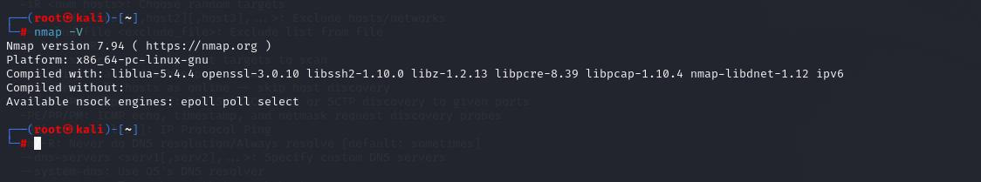

**AS we can see after typing nmap -v we are able to get the details of nmap version,platofrm and other details**

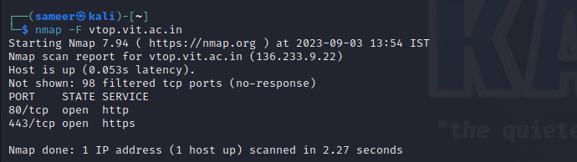

**As we can see after running the command nmap -f website we are able to see the open ports and ip address along as well**

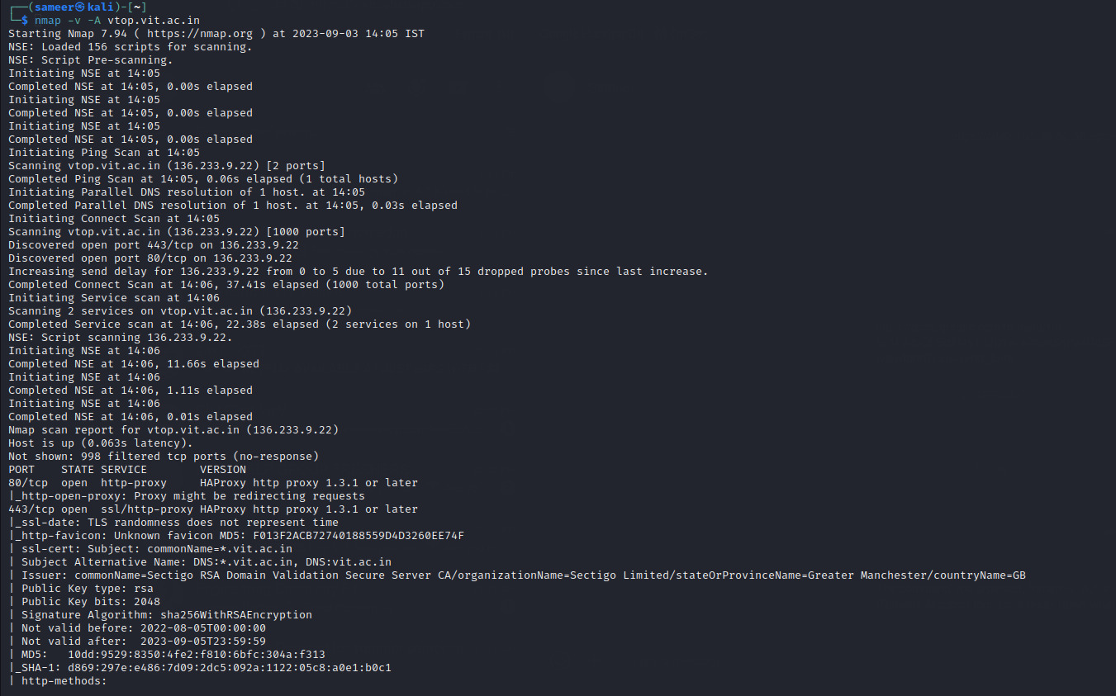

**The command "nmap -v -A," is used to perform a network scan with the Nmap (Network Mapper) tool.**

**-v means verbose mode -A means aggressive scaning**

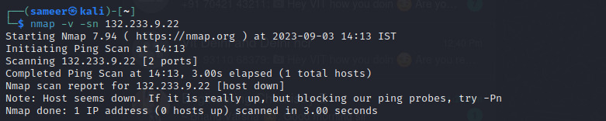

**Nmap -v -sn command means to host discovery scan**

**-v means verbose mode -sn means to ping scan**

**In this way we gather information using nmap tool to know about different open ports,whether host is up/down etc**

**2-Vulnerablity analysis-in this section we anaylse vulnerablity of a site by various tools**

**In this we we will study nikto tool-** 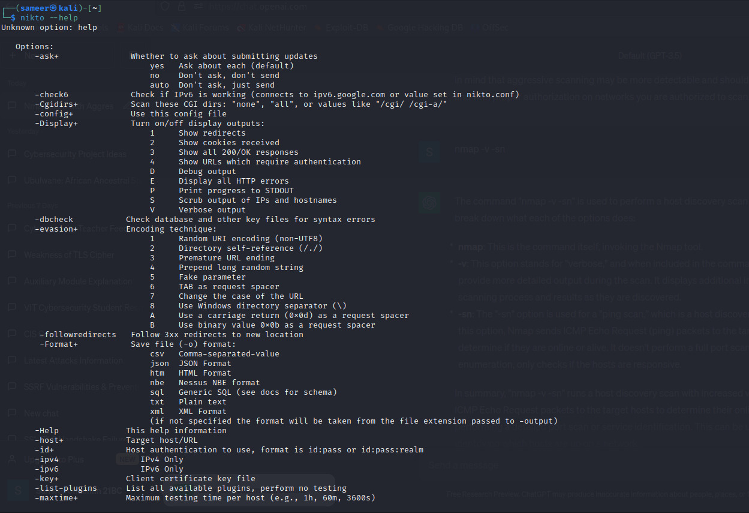

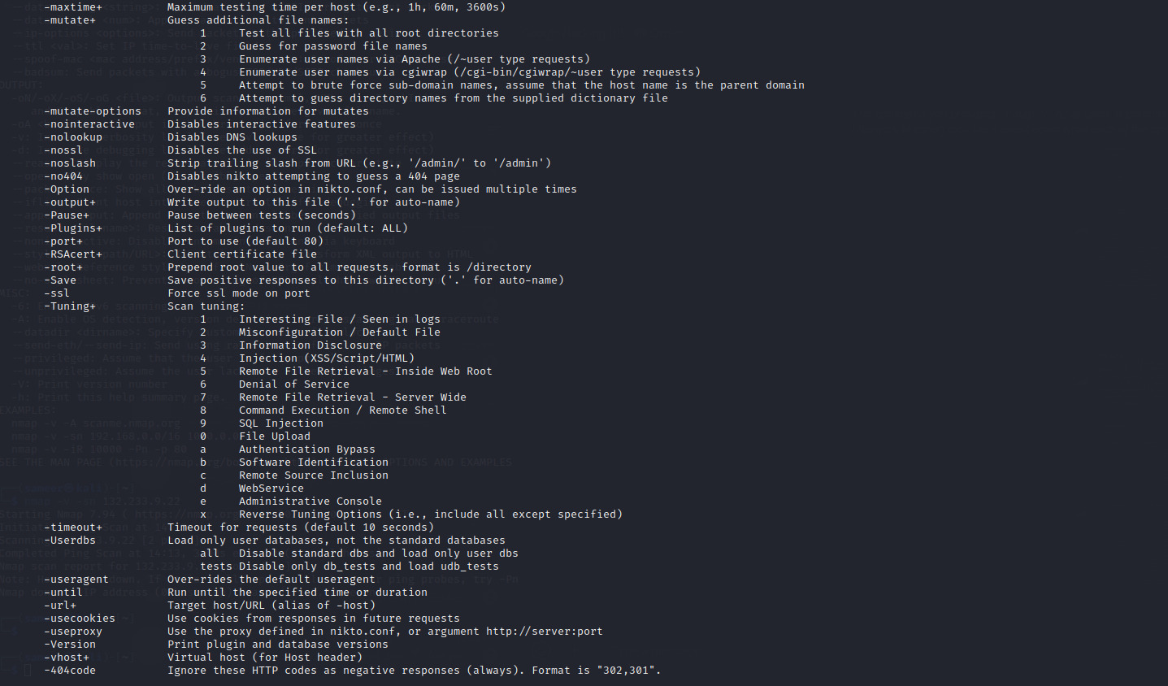**In order to use nikto we will type nikto – help it’s a pre installed tool in kali linux by typing this we got many options and commands we can explore using this tool as we can see in the above screenshot**

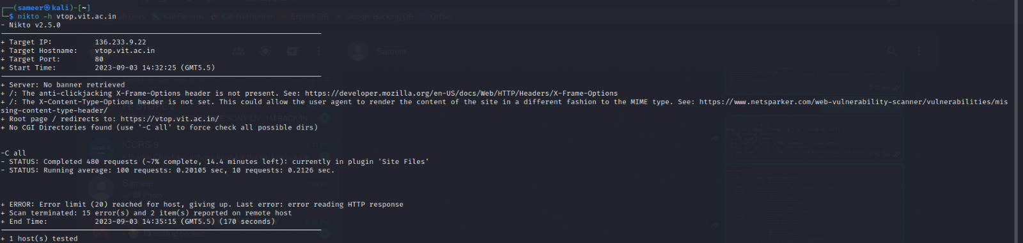

**By using the command nikto -h host name we will scan**

**It will gives us information like target ip, host name ,port ,time**

**Server name -but in this case not mentioned due to strict security**

**We only got some low findings only through this then it says type -c all to check all directories and then it will keep various directories after the website to check if something is visible like /passwords,/config but there was no as such found.**

**Like if we have to store the result of the scan in a documented file we can use nikto -h vtop.vit.ac.in -p 80 -o results -F txt**

**The disadvantage of this tool is that is is a very light weight tool it only gives us some vulnerability it doesn’t not scan in depth in real case scenarios 90 percent it doesn’t gives us any major vulnerability it can only gives us some low findings of a target website.**

**3 -Web application analysis -in this we have various tools like burpsuite ,sql map ,skip fish these are the tools which are used to anaylse web applications since I already know about burpsuite so I will explore a new tool in order to learn something new that is Skipfish tool**

**Skipfish tool-It is a web application anaylsis tool present in kali linux and it comes pre-installed**

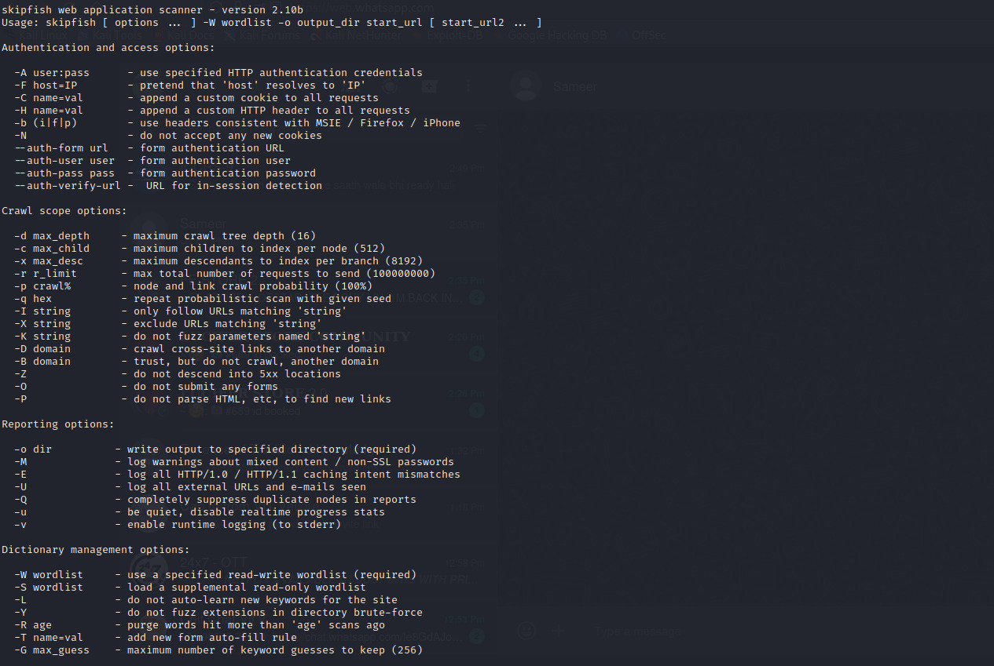

**As we can see after typing skipfish – h we can see help page of the tool here we are able to see different types of command like firstly we have authentication and access options for example we want to scan a site which have login credtionals so we can juse –auth-user and pass to login in that ,if we have to do deep scan then we can use -d ,if we have to save the file in a text form we can use -o**

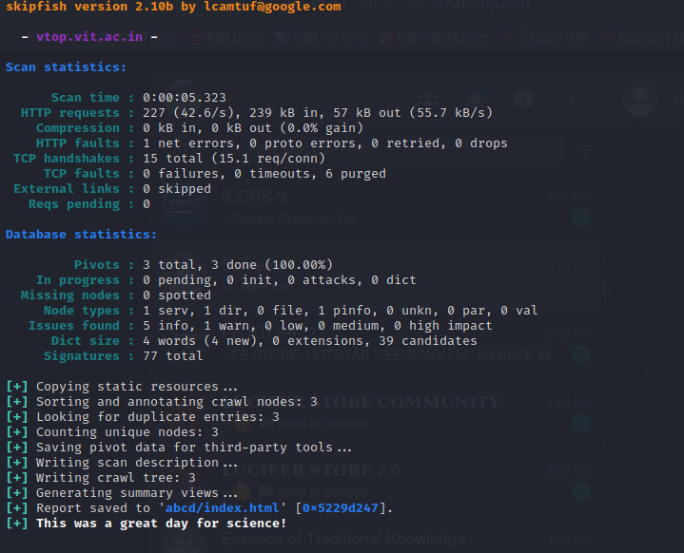

**By peforming the scan we got the following results**

**Firsly there is scan statistics-which shows scan time,HTTP requests ,number of tcp handshakes and per sec how many handhsakes,tcp faults which shows 0 packet failure ,we didn’t find any external links and req pending 0 means all the req are sent to targeted site**

**Then we have database statistics-pivot which are responsible for organization data in database which are 3 in total,we have o dict,missing nodes means html tags which are 0 ,signature are 77 it meas to verify since we didn’t have any in-flight req or external links so our scan was aborted after this.**

**Below scan we can index.html it means our all vulnerablity and scan related data are stored in this file so we go to home search abcd file name and we found indix.html we right click and open with firefox and we got this page** 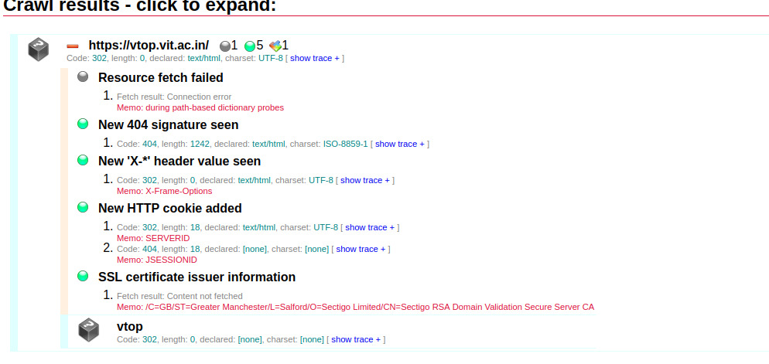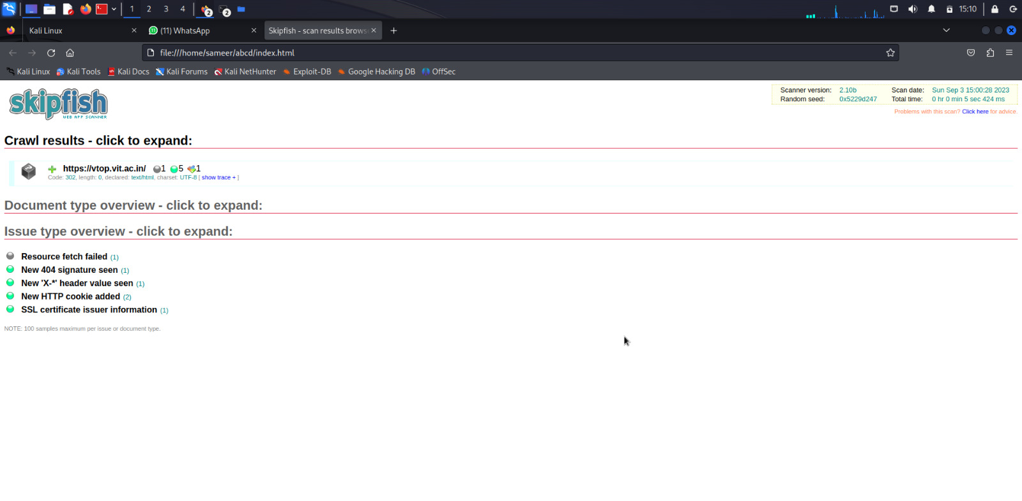

**Here we got varioius information like issue type,document type ,scanner version,time,date and all other details since the site is very much secure we only got some low findings**

**4-Database Asssement-In this we the main target is database security testing and to find out vulnerablity in a system and to determine whether its data and resources are protected from potential intruders**

**In this we will use tool SQL map-it is a open source tool that automatically finds and exploits SQL injection vulnerability**

**We can use this tool to dump data,exploit database data,even by pass logins**

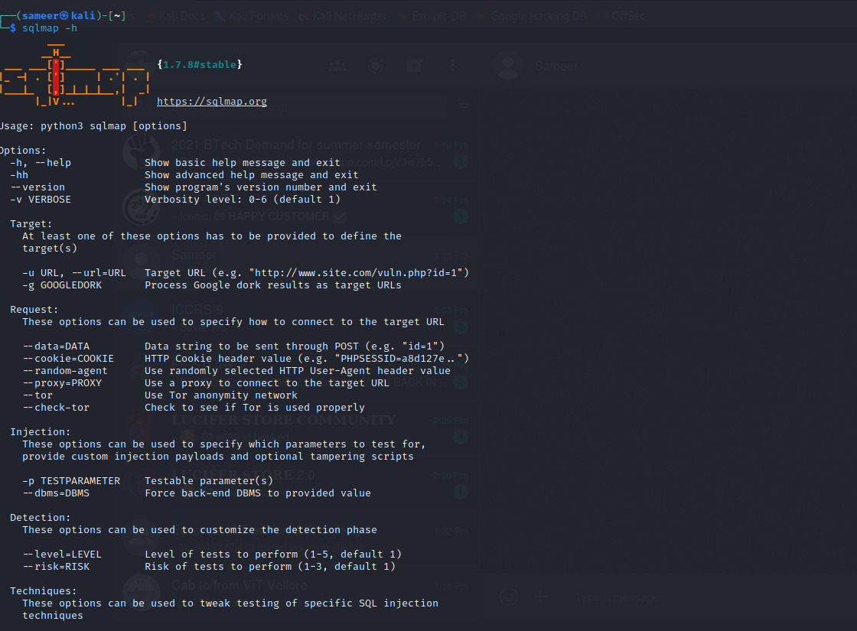

**Here we can see help page of SQL map by typing sqlmap -h or -hh for advanced help we can see here various commands we can use in this tool**

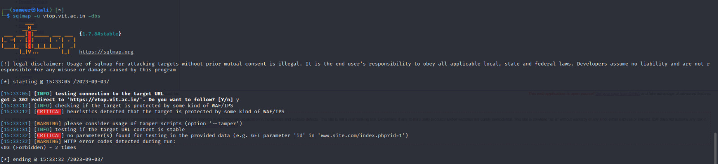

**here we can see that we get the information related to the site and it is protected by WAP/IPS**

**5-Passwords attack-this type help us to crack password of anything using brute force attack by using common word lists.**

**In this we will use n-crack tool-ALL IN ONE PASSWORD CRACKING AND AUDITING TOOL**

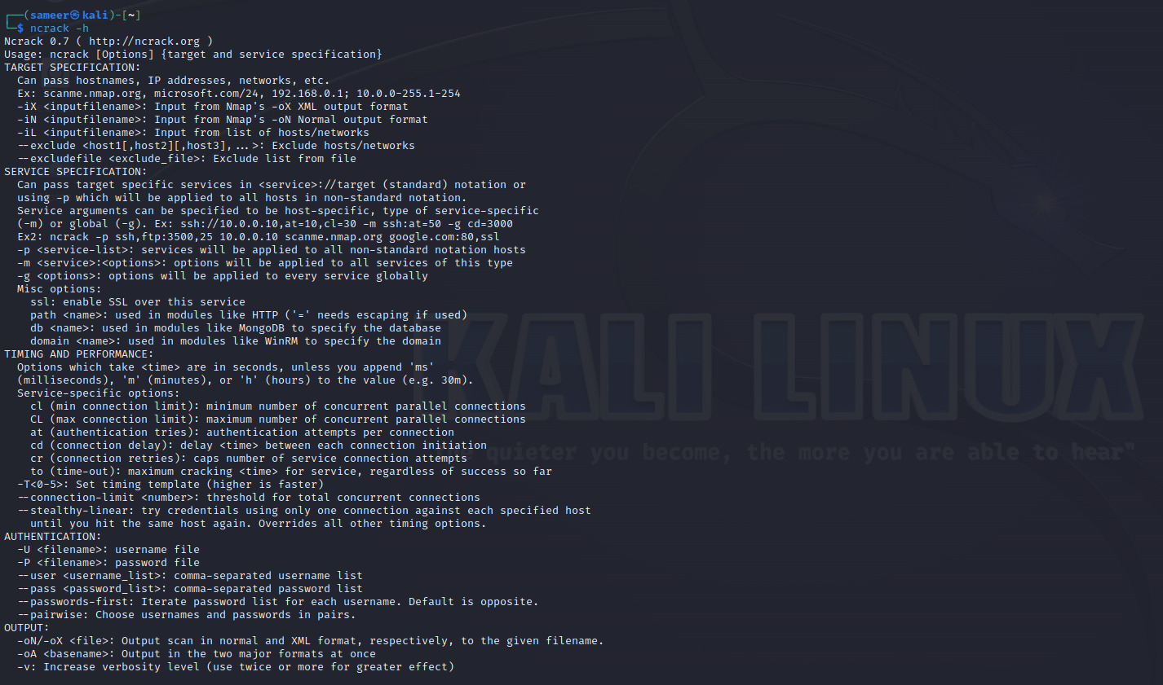

**After typing out ncrack -h we get the folloiwng help bar which shows us different options and command**

**In this we will peform anonymous ftp attack on our metasploit machine through ncrack attack-**

**First we will check if the ftp port is open or not by the typing the following command-**

**Nmap -p 21 192.168.154.128(target ip address metasploitable 2 machine )**

**We willl able too know that wether the port is open,closed or filtered**

**Since we known that the ftp port 21 is open so we will peform the attack**

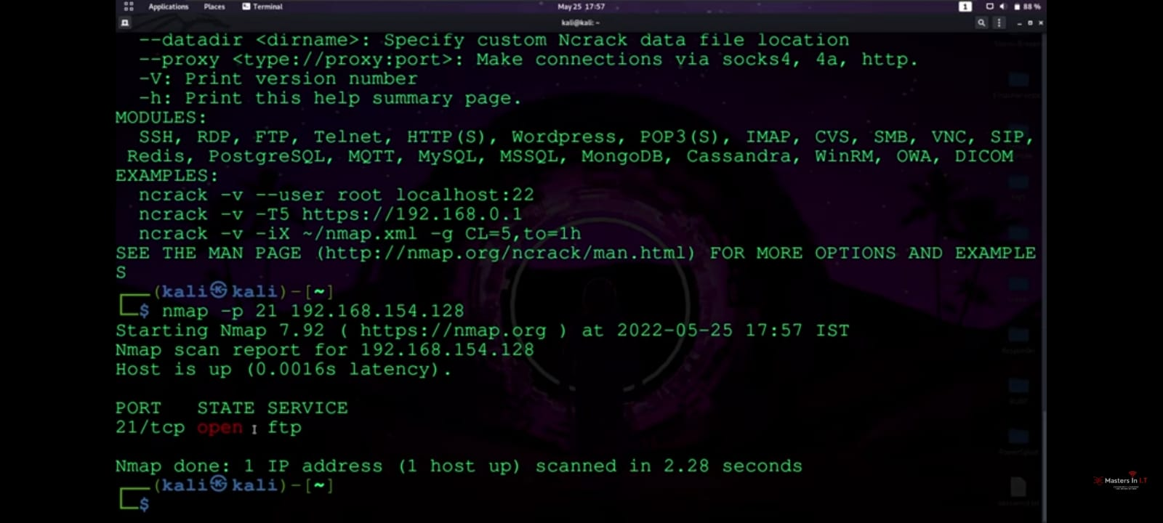

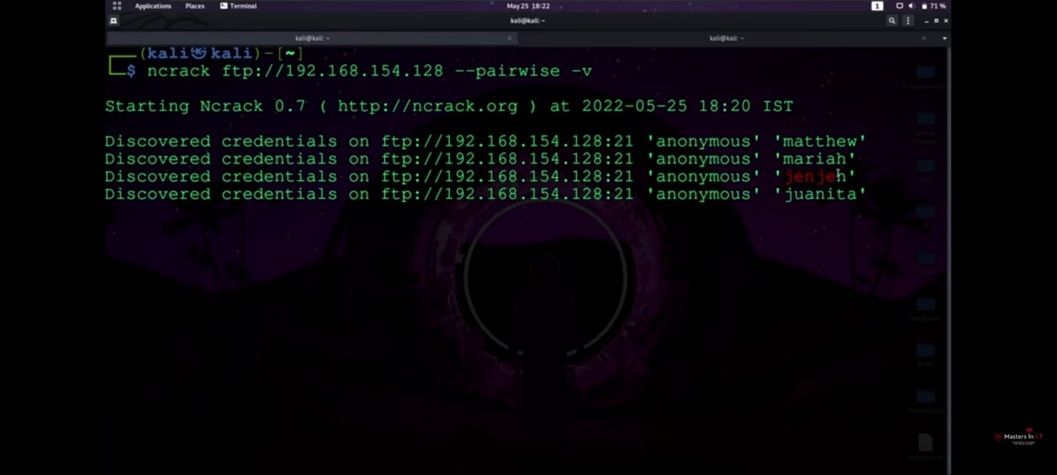

**After entering the command we noticed that the dictionary attack is being done by pre-installed word list in ncrack tool-**

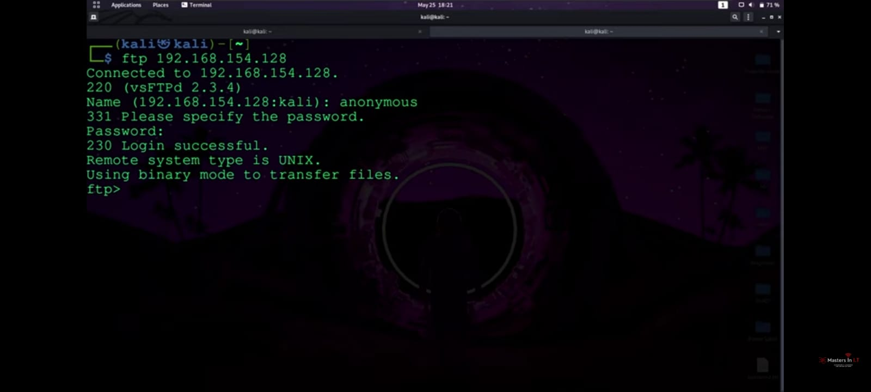

**Hence we see that we are able to crack the username and password of ftp login of our victim machine and gained access**

**So in this way we used ncrack to break the password**

**6-Wireless attacks-In this type of attack we try to hack wifi-password,hack WPA-WPA2 wifi passwords by using a wifi-adapter**

**So I have installed Realtek monitor external wifi-adapter for my demo**

**In this I will use aircrack-ng tool*- Aircrack -ng is a software suite for analyzing and hacking WiFi networks. Aircrack -ng functionality includes: Monitoring through packet capture and export of data to text files. This tool captures wifi handshake and then crack it with the help of brute force method and dictionary attack.***

***First we have to convert our wlan0 to monitor mode so it can monitor and capture the handshake file by doing wifi jamming***

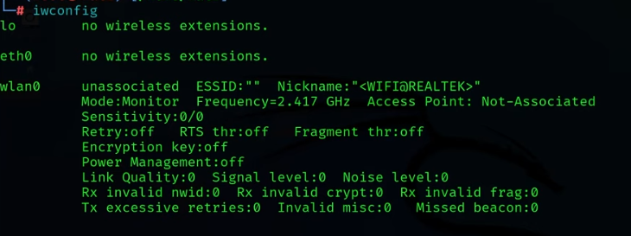

***Here as we can see wlan0 which is our external wifi adapter***

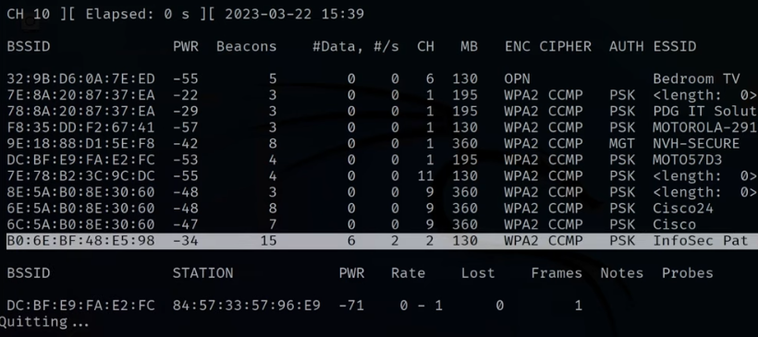

**Here we that handshake files are being captured- Now after giving some commands and doing brute force we cracked the handshake file that was captured by us**

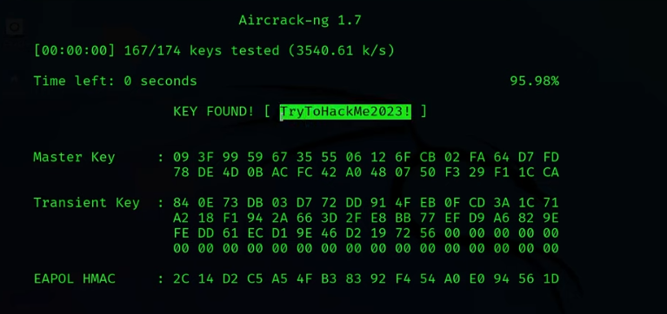

**7-Reverse Engineering- Reverse engineering in cybersecurity refers to the process of analyzing and understanding a piece of software, hardware, or a system by deconstructing it to uncover its inner workings, design, and functionality.**

**For this we will use APK TOOL-**

|  |  |
| --- | --- |
|  | **It is a tool for reengineering Android apk files that can decode resources to the nearly original form and rebuild them after the modification.**    **In this we are able to see apk tool details**    **By doing we are able to modify the apk installed on our kalli system**  **8-Exploitation tools-In this we have various types of tools which are used to exploit that includes Social engineering toolkit, Metasploit framework ,sql map ,msf payload creator.**  **In this we will explore Social Engineering toolkit which requires root access.**  **Like here we can see the toolkit, some of its details, first we have to do yes for accepting the terms and conditions.** |
|  |  |
|  | **After selecting the first social engineering attack we get these options to choose from** |

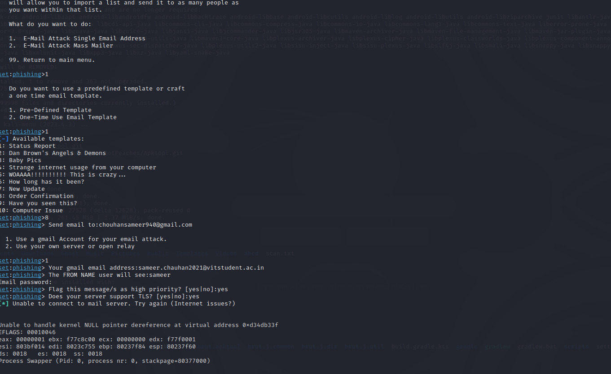

**As we can see we peformed spear phishing attack from client to receiver by using toolkit.**

**9-Sniffing and spoofing-** **Sniffing" and "spoofing" are two common techniques used in computer networking and cybersecurity, and they can be both used for legitimate and malicious purposes.**

**Here we will use netsniff-ng – the packet sniffing beast**

**It is a fast,minimal tool to anaylze network packets.**

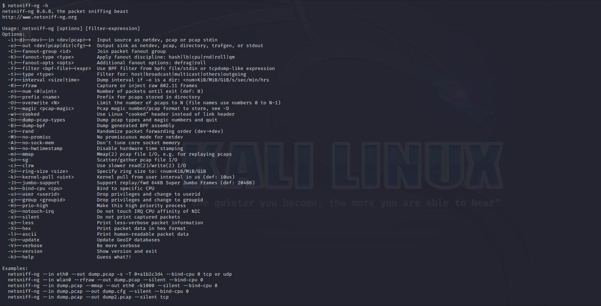

**Here we can various commands of the tool and its basic information**

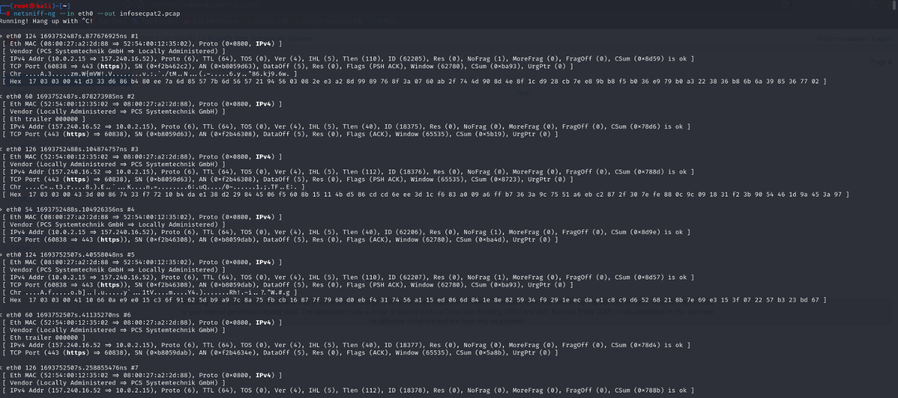

**Now we will use the command netsniff-ng eth0 –out infosec2.pcap**

**And it will start capturing the packets then we will visit the browser and start some websites ,do logins ,start facebook and after finishing we see the amount of captured packets and then we will open wireshark tool to anaylze the packets.**

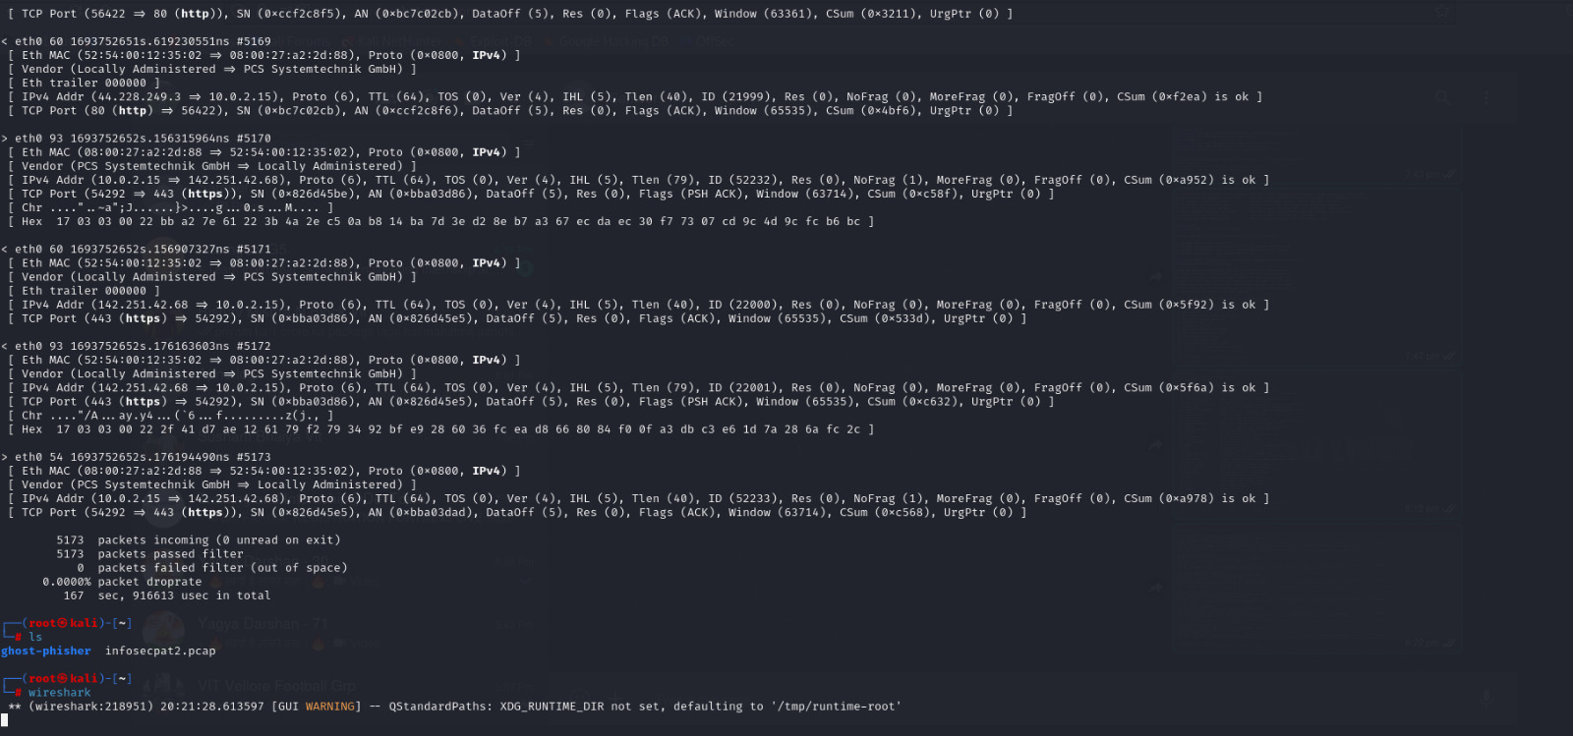

**Here at last we can see packets incoming,packets passed filter,packets failed filter**

**Now we will open wireshark tool**

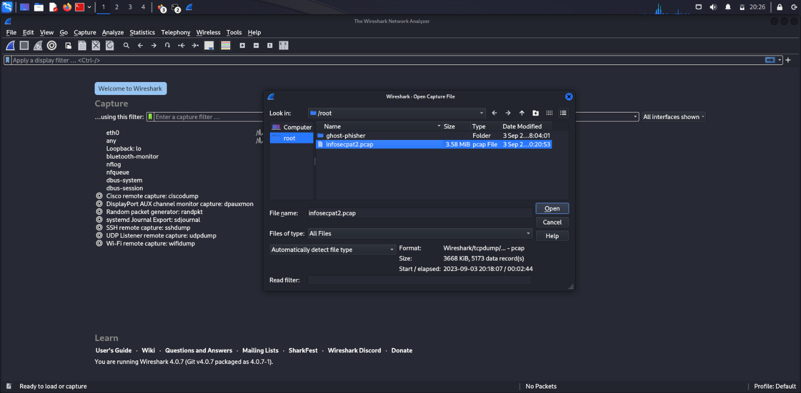

**Now we will open the file which we have created 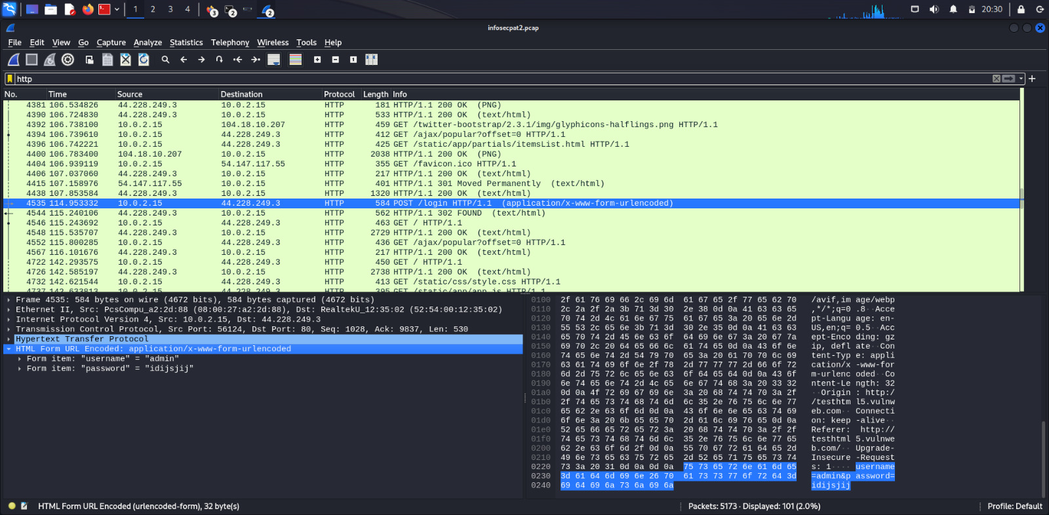 So here we can see the various packets we captured and we can also see our logins on the website, we can also filter tcp ,dns ,http to view more clearly**

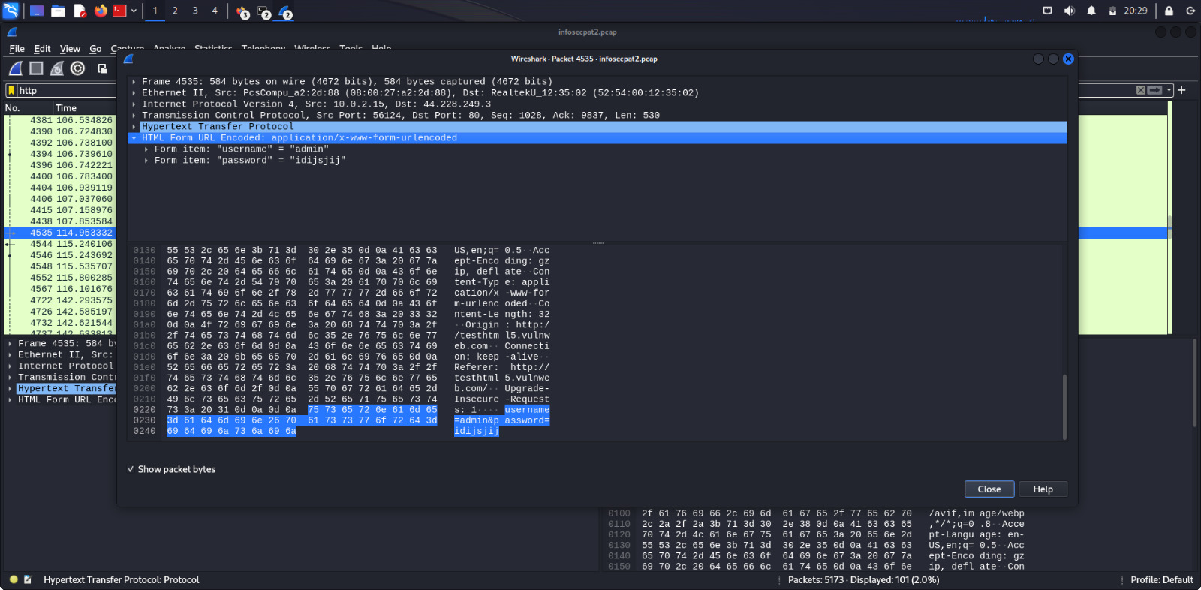

**10-Post Exploitation-** **Post-exploitation refers to the phase of a cyberattack where an attacker, having successfully compromised a target system, focuses on maintaining control, gathering information, and achieving their objectives**

**In this we will explore the tool Evil-WinRM is a penetration tool that exploits windows remote management service to gain unauthorized access to a remote windows system,it takes advantage of weak conifgurations present in WinRM service.**

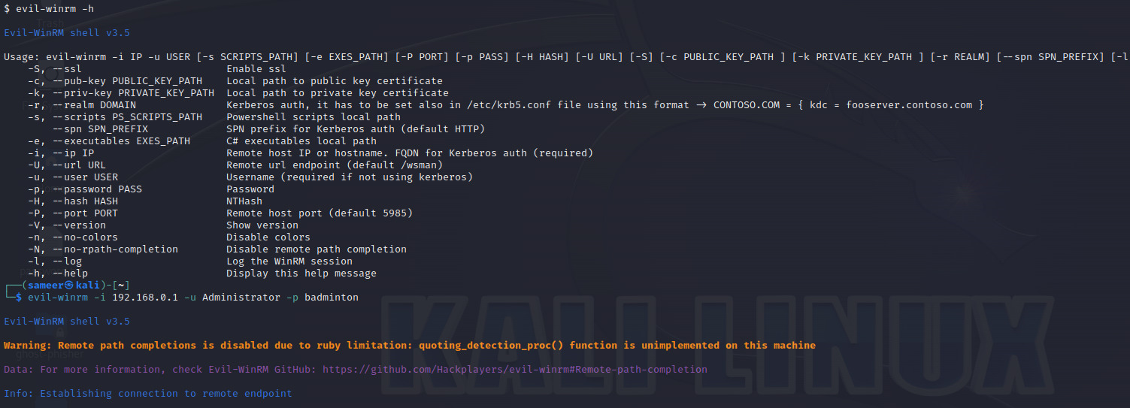

**We write the command evil-winrm-h and see the help menu there all the basic details of the tool is there,many commands are listed we can use**

**In this we will use another target machine which is metasploitable 2**

**We will give the command**

**Evil-winrm -i 192.168.0.1 -u Administrator -p badminton**

**After this we noticed that connection was establish to the remote endpoint and we could transfer the files as well**

**Inference -we successfully explored tools of each category of kalli linux as instructed by our teacher we able to know various tools and their functionality**